Frame

🧱 What Is a Frame in Networking?
# Source: Chatgpt (GPT‑5 Mini) at [12/14/2025]
A frame is a data structure used at the Data Link Layer (Layer 2) of the OSI model to encapsulate and transmit packets over physical media like Ethernet or Wi-Fi.

🧠 Simple Definition:
# Source: Chatgpt (GPT‑5 Mini) at [12/14/2025]
A frame is a container that wraps network data (like IP packets) with necessary information for delivery over a local network, including MAC addresses and error checking.

📦 Frame Structure (Ethernet Example)
# Source: Chatgpt (GPT‑5 Mini) at [12/14/2025]
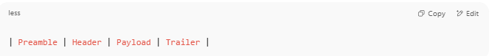
| Preamble | Header | Payload | Trailer |

🧾 Breakdown:
# Source: Chatgpt (GPT‑5 Mini) at [12/14/2025]
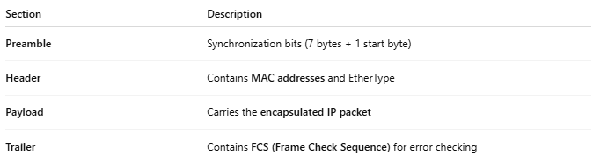
Section | Description
Preamble | Synchronization bits (7 bytes + 1 start byte)
Header | Contains MAC addresses and EtherType
Payload | Carries the encapsulated IP packet
Trailer | Contains FCS (Frame Check Sequence) for error checking

📄 Ethernet Frame Format (Typical)
# Source: Chatgpt (GPT‑5 Mini) at [12/14/2025]
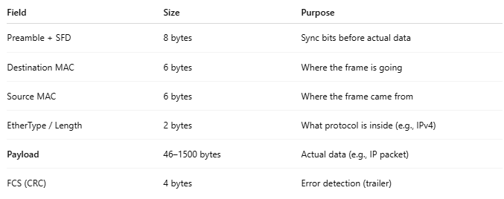
Field | Size | Purpose
Preamble + SFD | 8 bytes | Sync bits before actual data
Destination MAC | 6 bytes | Where the frame is going
Source MAC | 6 bytes | Where the frame came from
EtherType / Length | 2 bytes | What protocol is inside (e.g., IPv4)
Payload | 46–1500 bytes | Actual data (e.g., IP packet)
FCS (CRC) | 4 bytes | Error detection (trailer)

📡 What Frames Are Used For
# Source: Chatgpt (GPT‑5 Mini) at [12/14/2025]
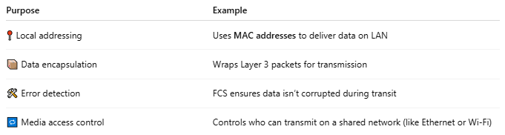
Purpose | Example
📍 Local addressing | Uses MAC addresses to deliver data on LAN
📦 Data encapsulation | Wraps Layer 3 packets for transmission
🛠 Error detection | FCS ensures data isn’t corrupted during transit
🔁 Media access control | Controls who can transmit on a shared network (like Ethernet or Wi-Fi)

📶 Types of Frames
# Source: Chatgpt (GPT‑5 Mini) at [12/14/2025]
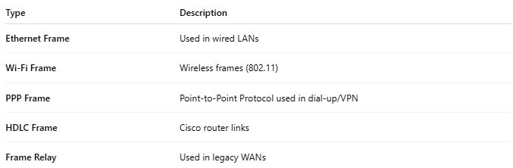
Type | Description
Ethernet Frame | Used in wired LANs
Wi-Fi Frame | Wireless frames (802.11)
PPP Frame | Point-to-Point Protocol used in dial-up/VPN
HDLC Frame | Cisco router links
Frame Relay | Used in legacy WANs

📌 Summary
# Source: Chatgpt (GPT‑5 Mini) at [12/14/2025]
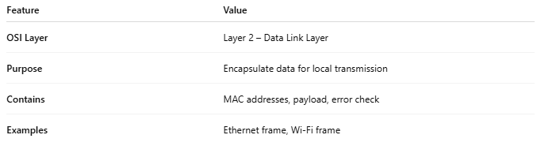
Feature | Value
OSI Layer | Layer 2 – Data Link Layer
Purpose | Encapsulate data for local transmission
Contains | MAC addresses, payload, error check
Examples | Ethernet frame, Wi-Fi frame

